

Task 4: Year 11 General Human Biology
Respiratory and Circulatory Systems Test

Time allowed –Working time for paper 60 minutes
Instructions to candidates
Answer the multiple choice questions on the answer sheet provided.
Write your answers to the short answer section in the spaces provided beneath each question
Answers that require a numerical answer should show all working out in logical steps.
Candidates should write clearly with a pen unless otherwise directed
Objectives
- The respiratory system is structured to facilitate the exchange of gases between the external environment and the blood
- The mechanics of breathing help to maintain the efficient exchange of gases in the lungs
- The circulatory system is structured to facilitate the transport of materials to and from exchange surfaces
- The structure of the heart facilitates the efficient flow of blood around the body
- The blood is made up of plasma and several types of blood cells, each with particular functions
- The function of the circulatory system can be compromised by cardiovascular diseases that reduce the
- efficiency of transport of materials around the body

Section | Marks | Possible score
Multiple Choice | 15
Written | 36
Total | 51

Section 1: Multiple choice (15 marks) Answer on the answer sheet provided.

- What is the respiratory system?
  - The body’s system of nerves
  - The body’s breathing system
  - The body’s food processing system
  - The system that transports blood

- What is an organ of the circulatory system?
  - The lungs
  - The brain
  - Blood vessels
  - The heart

- Which type of blood vessels carries blood TOWARD the heart?
  - Veins
  - Arteries
  - Capillaries
  - All of the above

- Which type of blood vessel facilitates GAS EXCHANGE?
  - Veins
  - Arteries
  - Capillaries
  - All of the above

- The left side of the heart pumps blood to
  - The body
  - The right side of the heart
  - The lungs
  - Aorta

- Oxygen in red blood cells is carried by
  - Hemoglobin
  - Chlorophyll
  - Diffusion
  - Mitochondria

- Gas exchange takes place in the
  - Bronchi
  - Alveoli
  - Bronchioles
  - Pharynx

- Which of the following statements is correct?
  - When air pressure outside the lung is greater than inside we breathe in
  - The pressure in the lungs must be greater than outside for us to breathe in
  - The pressure of the air outside must be lower than in in the lungs for us to breath in
  - There must be an equal pressure inside and outside the lungs for us to breath

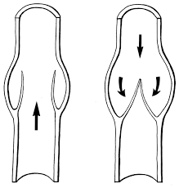
- What is the structure inside the vessel shown below?
  - Capillary
  - Muscle wall
  - Septum
  - Valve

- Based on the structure you identified in question 9, what type of vessel is this structure found in?
  - Vein
  - Artery
  - Capillary
  - Nerve

- What is the name of the pigment that allows red blood cells to carry oxygen?
  - Melanin
  - Hemoglobin
  - Plasma
  - Platelet

- What type of blood cell is shown to the right?

  - Red blood cell
  - Platelet
  - White blood cell
  - Plasma

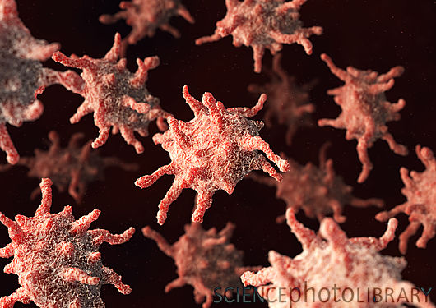
- If you measured your heart rate after doing a small amount of exercise and then compared it with your resting heart rate, which would be the DEPENDENT variable?

    - Resting or recovery heart rate
    - Type of exercise
    - Heart rate after exercise
    - The person who measured your heart rate

- When you exercise or perform short bursts of intense activity, you may feel a burning sensation in your muscles. What is this caused by and how does it relate to anaerobic respiration?

    - Buildup of carbon dioxide and less oxygen would be inhaled.
    - Heavy breathing to bring in more oxygen to revert back to aerobic respiration.
    - Less energy units (ATP) available from aerobic respiration, so, the body uses anerobic respiration
    - Buildup of lactic acid as a product of fermentation due to lack of oxygen in the body

- Which part of the blood fights of invading pathogens?

  - White blood cells
  - Red blood cells
  - Plasma
  - Platelets

MULTIPLE CHOICE
Question | Place a x in one box for each question
1 | a | b | c | d
2 | a | b | c | d
3 | a | b | c | d
4 | a | b | c | d
5 | a | b | c | d
6 | a | b | c | d
7 | a | b | c | d
8 | a | b | c | d
9 | a | b | c | d
10 | a | b | c | d
11 | a | b | c | d
12 | a | b | c | d
13 | a | b | c | d
14 | a | b | c | d
15 | a | b | c | d

Section 2: Written Section (31 marks)

16. In the diagram to the right, label in spaces marked 1-4, the sections of the circulatory system that are under high or low pressure. (4 marks)

In the spaces 5 and 6 correctly name the blood vessel identified. (2 marks)

17. In the image identify which is and artery and which is a vein and provide a reason for the differences observed. (3 marks)
_____________________________________________________________
_____________________________________________________________
_____________________________________________________________
_____________________________________________________________
_____________________________________________________________

18. Explain the function of plasma in the body, and list two things other than cells found in plasma. (3 marks)

______________________________________________________________________________________________________________________________
______________________________________________________________________________________________________________________________
______________________________________________________________________________________________________________________________

19. Name 2 conditions/dysfunctions of the circulatory system and effects they have on the body. (4 mark)

- Describe the process of inhalation: (4 marks)

______________________________________________________________________________________________________________________________________________________________________________________________________________________________________________________________________________________________________________________________________________________________________________

- List the organs of the respiratory system in the order that air would pass through them. The starting point has been given to you. (6 marks)

Nasal cavity/mouth --->

- Label the diagram below with the missing information. (2 marks)

1.
2.

- What passive form of transport is occurring in the above image? Explain how this process facilitates gas exchange in the lungs. (4 marks)

________________________________________________________________________________________________________________________________________________________________________________________________________________________________________________________________________________________________________________________________________________________________________________________________________________________________________________________________________________________________________________________________________________________________________________________________________________________________________________________________________________________________________________________________________________________________________________________________________________________________________________________________________________________________________________________________________________________________________________________________________________

- What is the material the supports the air passages in the respiratory tract? (1 mark)

______________________________________________________________________________________________________________________________

25. List the FOUR ways that the rate of gas exchange is increased in the alveoli. (4 marks)

1._____________________________________________________________________________________________________________
2.______________________________________________________________________________________________________________
3.______________________________________________________________________________________________________________
4.______________________________________________________________________________________________________________
End of Assessment

